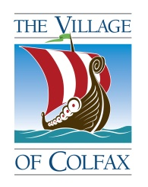 VILLAGE OF COLFAX
& the surrounding municipalities are hosting a Public Meeting
CHIPPEWA VALLEY TECHNICAL COLLEGE PRESENTATION
WHEN: Tuesday March 10, 2020 at 7:00 PM
WHERE: HIGH SCHOOL CAFETERIA
601 UNIVERSITY AVE, COLFAX WI 54730
The Chippewa Valley Technical College District Board of Trustees voted on January 16, 2020, to place a referendum question on the April 7, 2020 election ballot.
The referendum is for $48.8 million and would raise taxes on a $100,000 property approximately $13 annually. The funding would provide the following:
- A new transportation center to replace undersized, outdated auto and truck learning labs with larger modern labs, equipped to accommodate larger enrollments, training on gasoline, hybrid and electric vehicles, as well as “smart car” technology.
- Expand training facilities for police, fire, and paramedics to improve safety and protection for our campuses and communities.
- Purchase of land in River Falls for future expansion.
- New automated fabrication manufacturing lab.
- Upgrades in Chippewa Falls and Menomonie to improve safety and provide more programming.
- For more information, www.cvtc.edu/future.
Please join the community in becoming educated about what the referendum question is requesting. Get YOUR questions answered and be KNOWLEDGABLE about what you will be voting for on April 7th, 2020.
MAKE A DIFFERENCE
VOTE APRIL 7, 2020

